Final Project

Technology used: - Angular

Database used: - firebase

Topic-Students Details

I have made web application based on angular js and have used firebase for storing the data.

This application is for an schools dean who can monitor the details of the students enrolled in his school their name, enrollment number, department they are in, and the address of the students.

Application starts with the login page which matches the credentials and redirects the user to the main page if the login credentials are correct, in case if the login credentials are in corrects then an alert raise informing to enter correct username and password, following screenshots describe the process

1. Login page



1. In case of wrong password



After the dean logs in he can see the list of the details it is read operation of the crud.

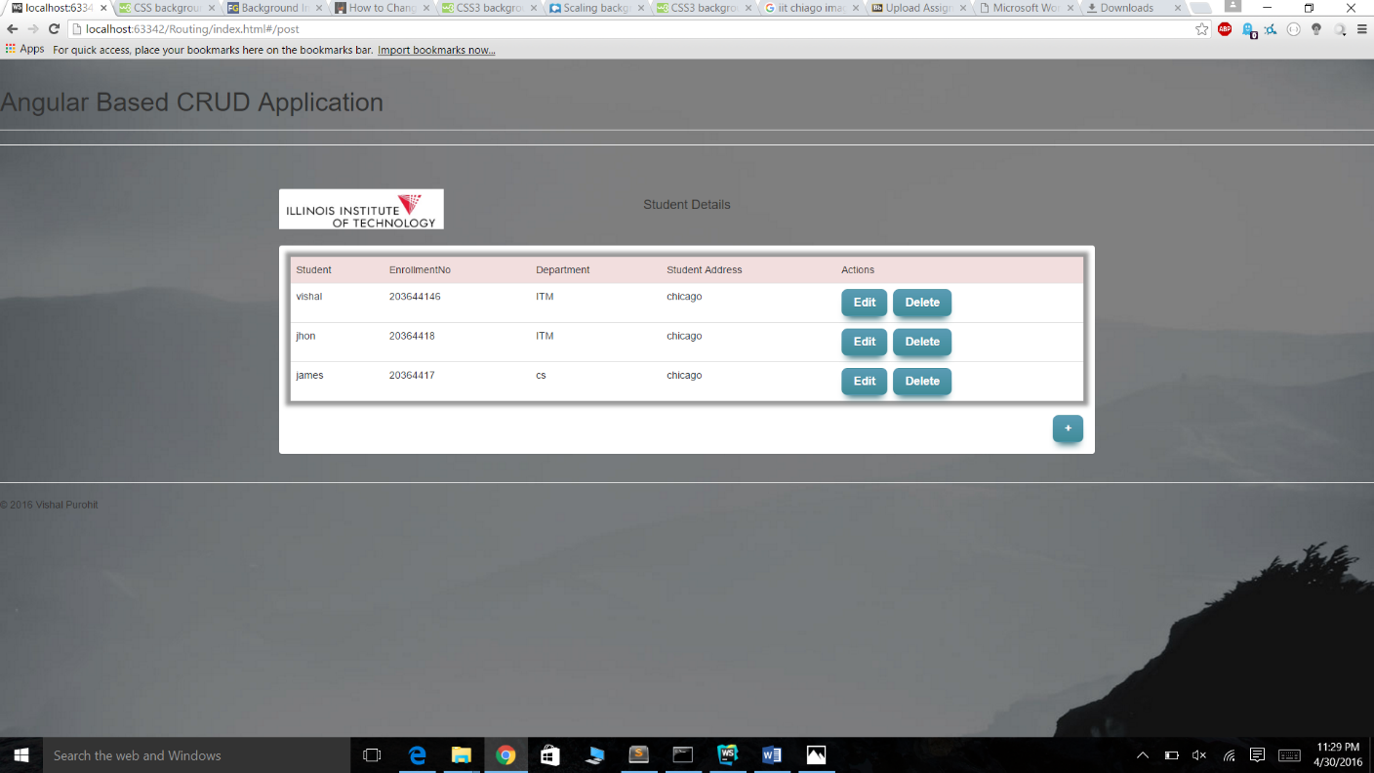

Here he can add new student detail which is the Create operation of crud

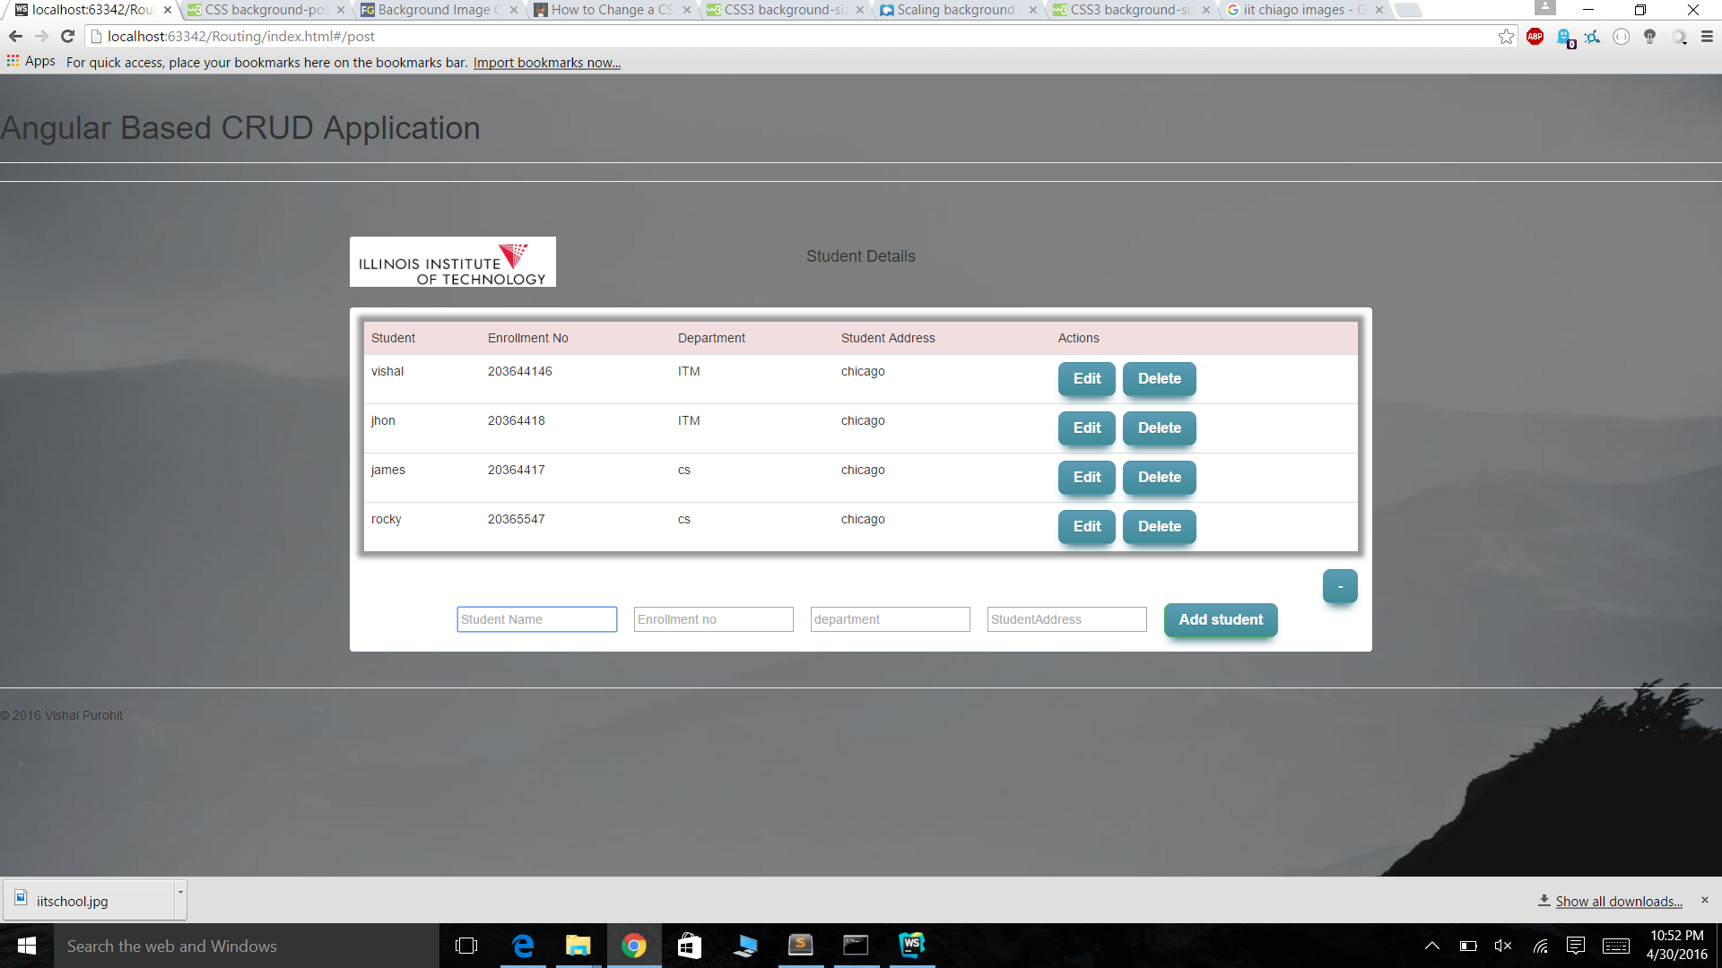

He can edit student detail

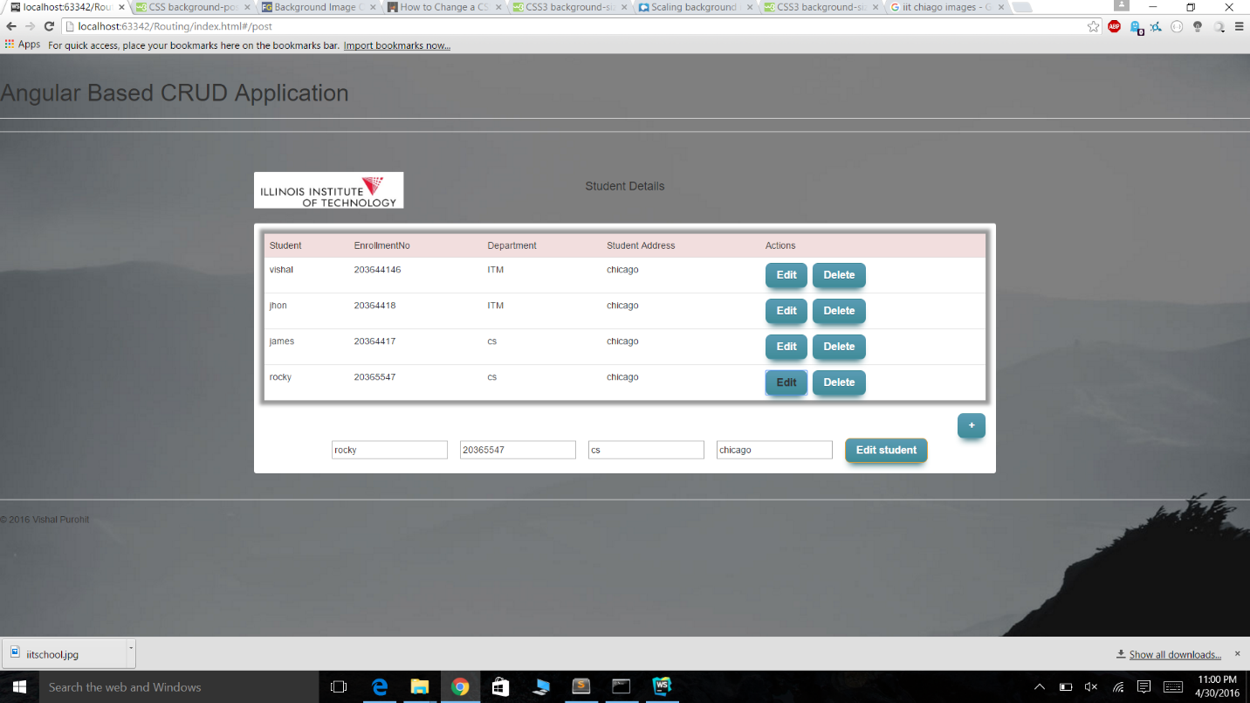

He can delete student detail

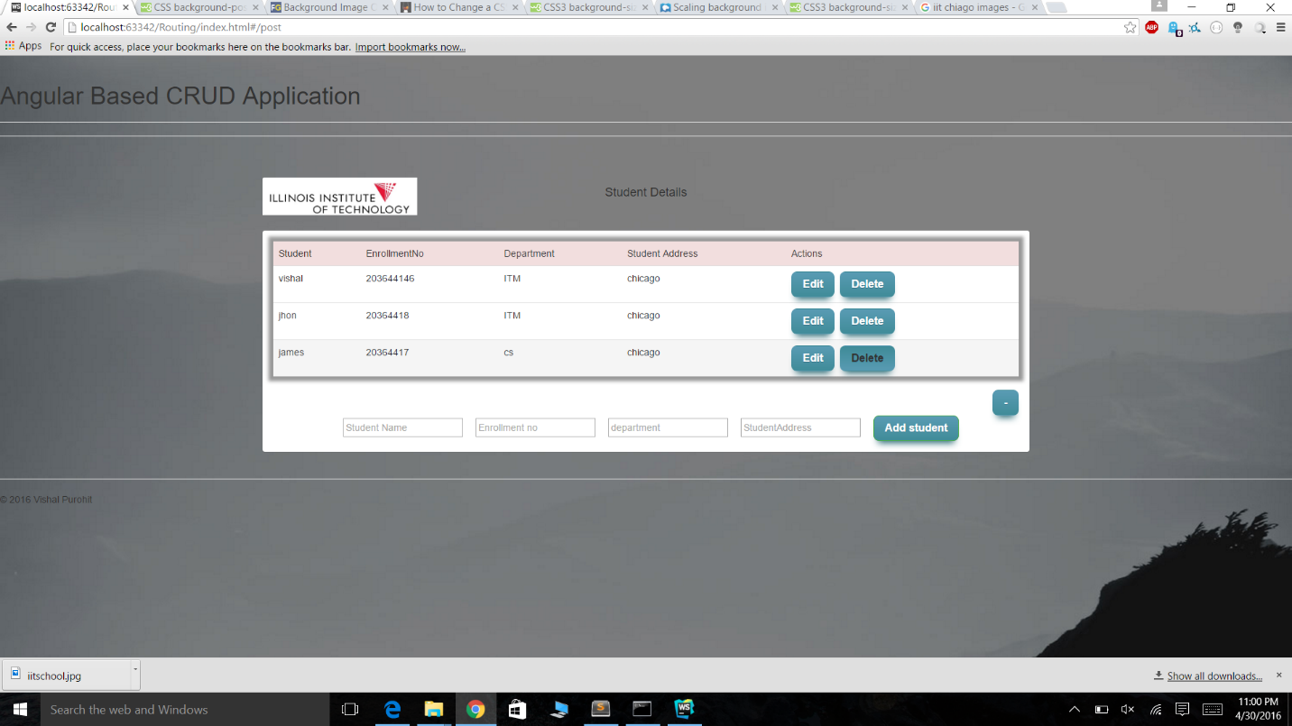

In this web application I have applied CRUD by using controllers controlling the flow of data between model and DOM Various directives, used various dependencies

Index.html has header and footer and have ng-view inside the section

In index.js I have angular routing that is ng-route which is responsible for routing pages implementing single page application concept

User-controller.js have login password authentication logics

Post-controller.js is responsible for all the CRUD operations using ng-repeat, ng-hide

Default.css have all the styles associated with the web application

Script.js created an angular module named myApp with multiple dependencies 'ngMessages','ngRoute','firebase'

In back end database I have used firebase and the data is residing in the database will implementing CRUD operations.

The login credentials are

**username:-finalproject**

**Password-finalproject**

**Execution Note:-**

Due to Cross browser error please open the project in webstorm and execute the project from index.html page

Issues faced

I was new to routing so it was challenging to implement that.